**Instruction and Application Manual**

**LSI ROS1 break apart probe (Orange, Green)**

-18ºC

**   **  

**IntellMed, Ltd.**

**Šlechtitelů 21**

**78371 Olomouc**

**Czech Republic**

**VAT: 27780317**

**DIC: CZ27780317**

### Probe location on chromosome

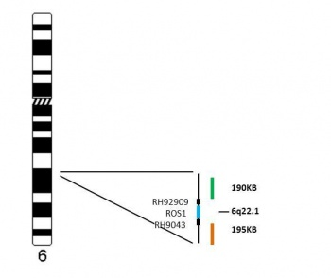

**Probe description**

The LSI ROS1 break apart probe FISH kit is intended for the determination of the ROS1 gene translocations in human tissues using fluorescence *in situ*hybridization (FISH).   
The LSI ROS1 break apart probe (Orange, Green) FISH kit contains two directly labeled fluorescent DNA probes in hybridization buffer. The fluorochrome Orange labeled ROS1 probe covers the 5’ end of ROS1 gene on chromosome 6q22.1 region. The fluorochrome Green labeled ROS1 probe covers the 3’ end of ROS1 gene on chromosome 6q22.1 region.   
The ROS1 (c-ros oncogene 1) gene is localized at the long arm of chromosome 6 and encodes the integral membrane protein with tyrosine kinase activity. The ROS1 gene translocation was described in association with glioblastoma and lung cancer. 2% of lung tumors, mainly adenocarcinomas, harbor the translocation of ROS1 gene. ROS1 translocation is mutually exclusive to EGFR and ALK mutations. The ROS1 translocation is the predictor of good response to the tyrosine kinase inhibitor crizotinib in lung tumors.

### FISH results

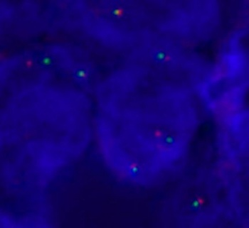

Fig.1

|  |  |  |
| --- | --- | --- |
| Fig. 1: An abnormal cell hybridized with the LSI ROS1 translocation probe (Orange, Green). The cell in this image shows the one orange/green fusion signal, and one orange and one separate green signal, which indicate the ROS1 translocation. |  |  |

red 5´        
green 3´

**References**

* Bergethon K, Shaw AT, Ou SH, Katayama R, Lovly CM, McDonald NT, Massion PP, Siwak-Tapp C, Gonzalez A, Fang R, Mark EJ, Batten JM, Chen H, Wilner KD, Kwak EL, Clark JW, Carbone DP, Ji H, Engelman JA, Mino-Kenudson M, Pao W, Iafrate AJ. ROS1 rearrangements define a unique molecular class of lung cancers. J Clin Oncol 2012;30(8):863-870.
* Davies KD, Le AT, Theodoro MF, Skokan MC, Aisner DL, Berge EM, Terracciano LM, Cappuzzo F, Incarbone M, Roncalli M, Alloisio M, Santoro A, Camidge DR, Varella-Garcia M, Doebele RC. Identifying and targeting ROS1 gene fusions in non-small cell lung cancer. Clin Cancer Res 2012;18(17):4570-4579.
* Birchmeier C, Sharma S, Wigler M. Expression and rearrangement of the ROS1 gene in human glioblastoma cells. Proc Natl Acad Sci U S A 1987;84(24):9270-9274.



R61

S24, S 25, S35, S36, S 37, S 39, S 45, S 53