**Instruction and Application Manual**

**LSI Her-2/neu(Orange)/CEP17(Green)**

**     **

**IntellMed, Ltd.**

**Šlechtitelů 21**

**78371 Olomouc**

**Czech Republic**

**VAT: 27780317**

**DIC: CZ27780317**

-18ºC

### Probe location on chromosome

### 

**Probe description**

**The Her-2/neu FISH kit is intended for the determination of Her-2/neu gene amplification in human tissues using fluorescence in situ hybridization (FISH).**

**The Her-2/neu FISH kit is CE marked and can be used for in vitro diagnostic tests.**

The Her-2/neu FISH kit contains two directly labeled fluorescent DNA probes in hybridization buffer. The fluorochrome Orange labeled Her-2/neu probe covers the chromosome 17q11-12 region. The fluorochrome Green labeled chromosome enumeration CEP17 probe covers the chromosome 17p11.1-q11.1 region.

The Her-2/neu (Human Epidermal Growth Factor Receptor 2 also known as Neu) gene codes for a 185 kDa transmembrane receptor with tyrosine kinase activity and belongs to the EGF (epidermal growth factor) receptor family. Her-2/neu gene is amplified in 15-30% of breast cancer, and less frequently in other cancers, e. g. lung, pancreatic, ovarian, or stomach cancer. The Her-2/neu gene amplification is strongly associated with increased disease recurrence and worse prognosis. Breast cancer patients with Her-2/neu gene amplification are treated with monoclonal antibody p185Her-2 trastuzumab (Herceptin) and/or tyrosin kinase inhibitors (lapatinib, Tyverb).

### FISH results

The copy number of Her-2/neu and CEP17 is evaluated in at least 100 cell nuclei in histologically verified section of tissue. A ratio of Her-2/neu/CEP17 higher than 2.2 is considered to be true amplification. Ratio between 1.8 and 2.2 is necessary to interpret as a borderline value, and to take account of the result of immunohistochemical staining. Under normal status is considered ratio <1.8.

Normally observed in cell two orange signals (Her2/neu) and two green signals (chromosome 17) (Fig. 1a). Figure 1b shows the polyploidy of chromosome 17, accompanied by a higher copy number of Her2/neu gene (pseudo-amplification). True amplification, i.e. a higher number of Her2/neu gene copies with a normal number of chromosome 17, is shown in figure 1c.

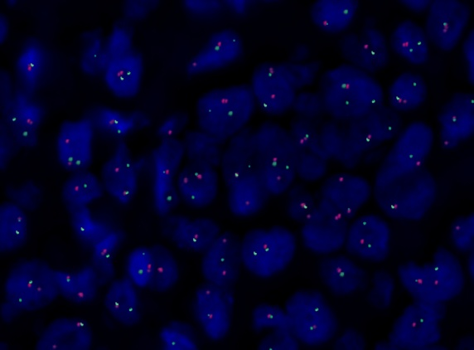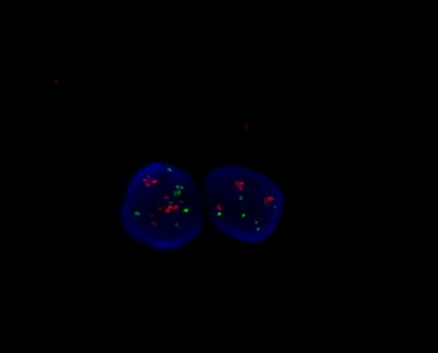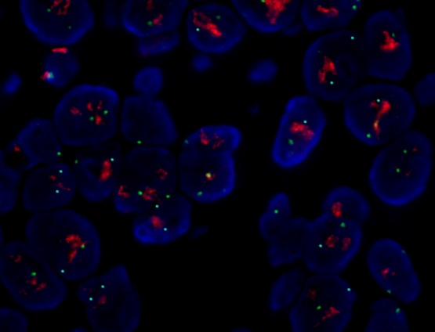  
 1a 1b 1c

Figure 1: Assessment of the copy number of Her-2/neu gene and the copy number of chromosome 17 on FFPE tissue.

red LSI Her-2/neu   
green CEP17  
a) Two copies of Her-2/neu genes as well as chromosome 17 in cell (physiological finding).  
b) Polyploidy of chromosome 17 with a higher copy number of Her-2/neu gene (pseudo-amplification).

c) Normal copy number of chromosome 17, higher copy number of Her-2/neu gene (true amplification).

**References**

* Slamon DJ, Clark GM, Wong SG: Human breast cancer: Correrlation of relapse and survival with amplification of the Her-2/neu oncogene. Science 1987; 235: 177-182.
* Perez EA: Her2 as a prognostic, predictive, and therapeutic target in breast cancer, JMCC 1999; 6: 233-240.
* Shak S: Overview of trastuzumab (Herceptin) anti-Her2 monoclonal antibody clinical program in Her2- overexpressing metastatic breast cancer. Semin Oncol 1999; 26: 71-7.
* Ross JS, Fletcher JA: The  Her-2/neu oncogene : prognostic factor , predictive factor and target for the therapy. Semin Cancer Biol 1999; 9: 125-138.
* Lebeau A, Deimling D, Kaltz Ch., Sendelhofert, Iff A, Luthardt B, Untch M, Löhrs U: Her-2/neu analysis in archival tissue samples of human breast cancer: comparsion of immunohistochemistry and fluorescence in situ hybridization. J Clin Oncol 2001;19: 354-63.



R61

S24, S 25, S35, S36, S 37, S 39, S 45, S 53